Name : Bhavesh Punjabi
Roll no : 40

Experiment 2: To Perform Data Preprocessing Using Python
Aim
To perform data preprocessing using Python by handling missing values, removing duplicate records, encoding categorical data, and scaling numerical features.
Objectives
● Load a dataset using Python.
● Identify and handle missing values.
● Remove duplicate records.
● Convert categorical data into numerical form.
● Normalize/standardize numerical data.
● Prepare clean data for further analysis or machine learning.
Software/Tools Required
● Python 3.x
● Jupyter Notebook / Google Colab
● Pandas
● NumPy
● Scikit-learn
Theory
Data Preprocessing Data preprocessing is the process of converting raw data into a clean, consistent, and suitable format for analysis or machine learning. Real-world datasets may contain missing values, duplicate records, categorical attributes, and numerical features with different ranges. These issues can affect the accuracy and reliability of data analysis. Therefore, preprocessing is performed before applying analytical or machine-learning techniques.
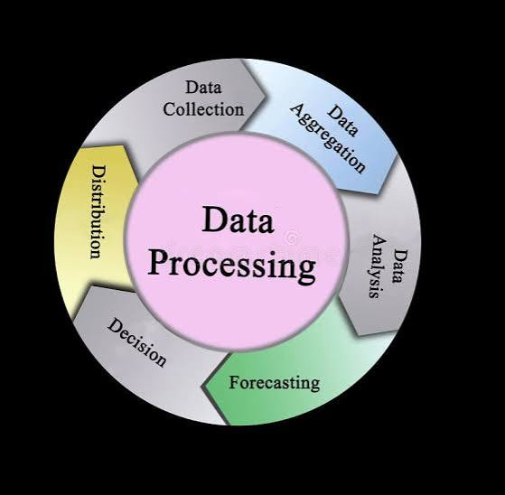
Common preprocessing steps are:
1. Data Cleaning – Handling missing and incorrect values.
2. Removing Duplicates – Eliminating repeated records.
3. Encoding – Converting categorical values into numerical values.
4. Feature Scaling – Bringing numerical features to a similar scale.
5. Data Transformation – Converting data into a suitable format.
Python Program :
import pandas as pd
import numpy as np
from sklearn.preprocessing import LabelEncoder, StandardScaler

# 1. Load Excel dataset
file_path = "/content/Movie_Ticket_Booking_Sample_Dataset.xlsx"
df = pd.read_excel(file_path)

print("===== ORIGINAL DATASET =====")
print(df)

# 2. Check missing values
print("\n===== MISSING VALUES =====")
print(df.isnull().sum())

# 3. Handle missing numerical value
df["Age"] = df["Age"].fillna(df["Age"].mean())

# 4. Handle missing categorical value
df["Payment_Method"] = df["Payment_Method"].fillna(
df["Payment_Method"].mode()[0]
)

print("\n===== MISSING VALUES AFTER HANDLING =====")
print(df.isnull().sum())

# 5. Check duplicates
print("\n===== DUPLICATES =====")
print("Duplicate rows:", df.duplicated().sum())

# 6. Remove duplicates
df = df.drop_duplicates()

print("Duplicates after removal:", df.duplicated().sum())

# 7. Encode Gender
gender_encoder = LabelEncoder()
df["Gender"] = gender_encoder.fit_transform(df["Gender"])

print("\nGender Encoding:")
print(gender_encoder.classes_)

# 8. Encode Booking Status
status_encoder = LabelEncoder()
df["Booking_Status"] = status_encoder.fit_transform(
df["Booking_Status"]
)

print("\nBooking Status Encoding:")
print(status_encoder.classes_)

# 9. Select numerical columns
numerical_columns = [
"Age",
"Tickets",
"Ticket_Price",
"Total_Amount"
]

# 10. Feature scaling
scaler = StandardScaler()

df[numerical_columns] = scaler.fit_transform(
df[numerical_columns]
)

# 11. Display final dataset
print("\n===== FINAL PREPROCESSED DATASET =====")
print(df)

# 12. Final verification
print("\n===== FINAL CHECK =====")
print("Missing values:")
print(df.isnull().sum())

print("\nDuplicate rows:")
print(df.duplicated().sum())

# 13. Save preprocessed dataset
output_file = "/content/Preprocessed_Movie_Ticket_Booking.xlsx"

df.to_excel(output_file, index=False)

print("\nPreprocessed dataset saved successfully!")

Expected Output :
1.Loading data
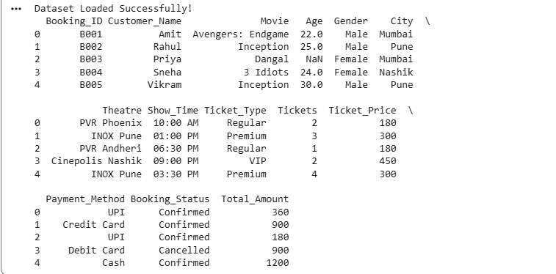
2. Dataset Size
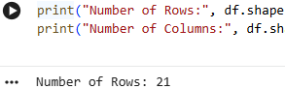

3. Checking Duplicate and Missing values
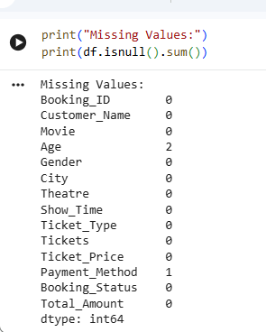
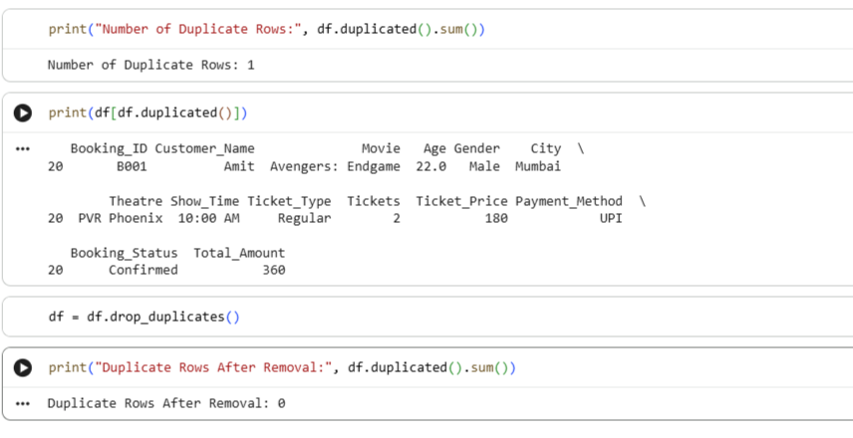

4.Encoding categorial data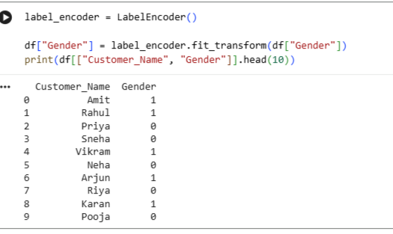
5.Feature scaling 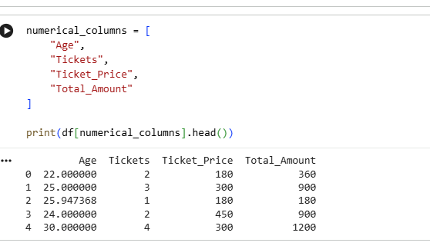
6.Final Preprocessed Data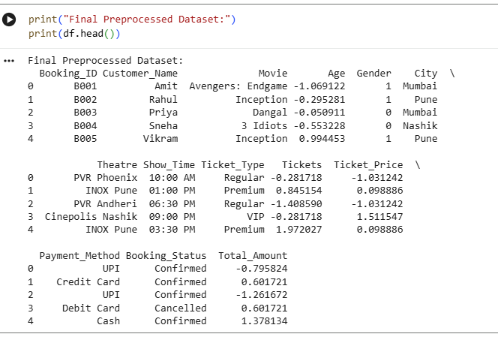

Conclusive Result — Business Strategy and Implementation
Conclusion
The Movie Ticket Booking System can use the preprocessed booking data to support better business decisions. After handling missing values, removing duplicate bookings, encoding categorical information, and scaling numerical features, the data becomes more reliable and suitable for analysis and future machine-learning applications.

Business Strategy :
Based on the dataset, the business can adopt the following strategies:
- Customer Segmentation
Analyze customer age, gender, city, and booking behavior to identify different customer groups.
- Movie Demand Analysis
Compare the number of bookings for different movies to identify high-demand and low-demand movies.
- Dynamic Pricing
Ticket prices can be adjusted according to movie popularity, show timing, theatre, and demand.
- Targeted Promotions
Customer and booking information can be used to provide suitable discounts and offers for different customer segments.
- Theatre and Show Optimization
Booking trends can help management allocate more screens or popular show timings to high-demand movies.
- Revenue Improvement
Analysis of ticket quantity, ticket price, and total booking amount can help identify opportunities to increase revenue.

Implementation
The implementation can follow this process:
Movie Booking Data
↓
Data Collection
↓
Data Preprocessing
↓
Missing Value Handling
↓
Duplicate Removal
↓
Categorical Encoding
↓
Feature Scaling
↓
Data Analysis
↓
Business Decisions
↓
Improved Pricing, Promotions & Show Allocation

Result
Thus, the Movie Ticket Booking System demonstrates how data preprocessing can convert raw booking information into clean and reliable data for business analysis. The processed data can help management understand customer behavior, movie demand, ticket sales, and revenue patterns, enabling better decisions regarding pricing, promotions, theatre allocation, and show scheduling. This provides a foundation for implementing data-driven business strategies and future machine-learning solutions.

============================================================
GitHub Repository Link:
https://github.com/Sentry2311/DMBI_EXPERIMENTS/tree/main/Experiment_02_Data_Preprocessing_Python
(Contains complete documentation, dataset, and program code for Experiment 2: Data Preprocessing Using Python)

